Week 1 Day 1-2: Introduction to the PBI project

First half of period:
Monday Math Fun Day
Materials:
Paper
pencil
Book: “Math: Tricks, Puzzles, and Games” by Raymond Blum
Activities:
Using given Math brain puzzle, the students will come up with a creative answer: Similar to “Math: Tricks, Puzzles, and Games” by Raymond Blum page 45, In Need of Repair:
“Add only one straight line to this equation so that it is correct.
5 + 5 + 5 = 550”
- The students will write their answer and justification in half of the page provided.
- In groups of 3, the students will present to their peer how they solve it and compare their answers. They will need to choose the answer and approach that they think is the most accurate in applying previous math concepts.
- The students will present their choice to their classmates.
- Students will write a small paragraph about what they learn from solving this problem.

Second Half of Period:
Discussion:
The students will take few minutes to answer the following question.
Can math concepts be applied at real life? Explain your reasons and support your claim by providing examples that you know.
We will discuss our answers.
Activity:
- Anchor video:
https://www.youtube.com/watch?v=uaGckPEyveE&feature=youtu.be
- Write group contracts.
As a class, we will talk about the responsibilities of the members of a project team. We will be writing ideas in the board on what are the contract contract should be.

“Math: Tricks, Puzzles, and Games” by Raymond Blum page 45, In Need of Repair:
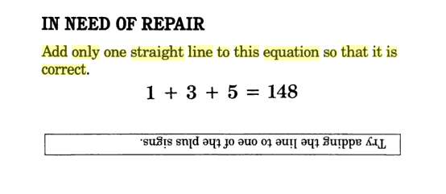

Puzzle:
“Add only one straight line to this equation so that it is correct.
5 + 5 + 5 = 550”
Teacher Key:
- There are four correct answers:
  - Cross out the equal Sign
  - Turn the first + into a 4 giving 545 + 5 = 550
  - Turn the Second + into a 4 giving 5 + 545 = 550
  - Turn the equal sign into not equal or less than or equal to

Benchmark Lesson Week 1 Day 3-5: One-Step Equations
by Grizel Macias and Rebecca Breeding
- Grade Levels: 7th- 8th grades
- Time Requirements:
  - Approximately 2 hours Preparation Time and 3 hours Class Time.
- State Standards:
  - CCSS.Math.Content.8.EE.C7
  - CCSS.Math.Content.8.EE.C7. A
  - CCSS.Math.Content.8.EE.C7. A

Math/Science Objective:
  - Students will recognize that the equal sign represents a balance between two sides of an equation.
  - Students will comprehend that in order to maintain the balance of an equation, the same things must be added or removed from both sides.
  - Students will understand that creating zero pairs with the algebra tiles is the same as performing the inverse operation.
  - Students will be able to solve for the variable in a one-step equation with addition or subtraction.
  - Students will represent a one-step equation with algebra tiles and use the tiles to solve for the variable.
- Brief Overview:
This unit lesson is designed as an introduction to one-step equations. In the first lesson, students will work strictly with models and word sentences. The main objective for the first day is to introduce and reinforce important vocabulary pertaining to solving one-step equations, as well as to write and construct equations from given word sentences and models. The second day, the students will write key characteristics of one-step equations. We will move to solve them. The students will discover and learn how to isolate the variable when solving a one-step equation.
This unit is designed to promote strong interpersonal skills, as may other activities require cooperative learning and idea sharing between students.

- Lesson Features:

- Video game for students to practice solving one step equations for Friday:
https://www.mangahigh.com/en-us/games/algebrameltdown

http://www.sheppardsoftware.com/mathgames/Numberballs_algebra_I/numberballsAlgebraI.htm
- Teaching Strategy:
Cooperative learning: Students will work in groups to solve few one-step equations and discuss their method of solving. They also would revise their answers and discuss any differences they find.
- Games/ Experiments/simulations- games, experiments and simulations, Kahoot!
- Interactive features: Foldable (Hamburger fold) with the students to take notes.
- Vocabulary Worksheet
- Materials Required For This Lesson:
  - Material A:
Pencils
Pens
Algebra tiles
Color paper
Scissors
Glue
Class set of individual white boards
Vocabulary worksheet

